**Computing Systems**

In this challenge, we had to configure a windows server, in which inside we had to install and configure things like: backups, users, groups, UO, DHCP, DNS, shared folders. Apart from this we had to do a packet tracer to design the network.   
  
To start with the windows server we have created these users with their respective IP:

The windows server will have **192.168.0.1** IP

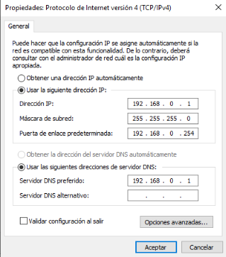

The Domain name is **joks.lan**

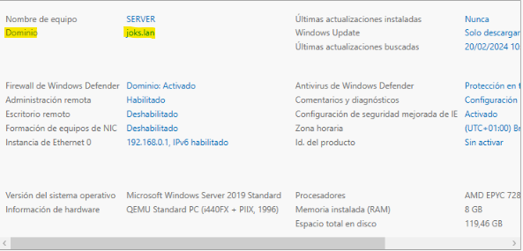

The users are in a OU called **JOKS**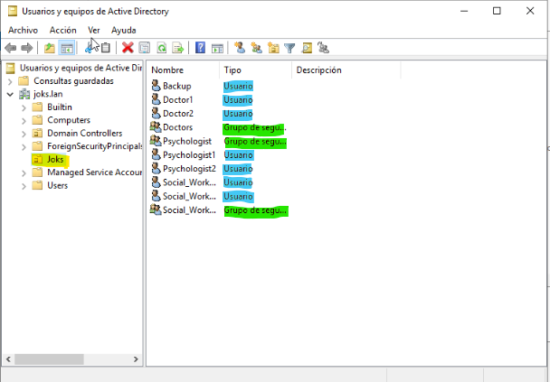

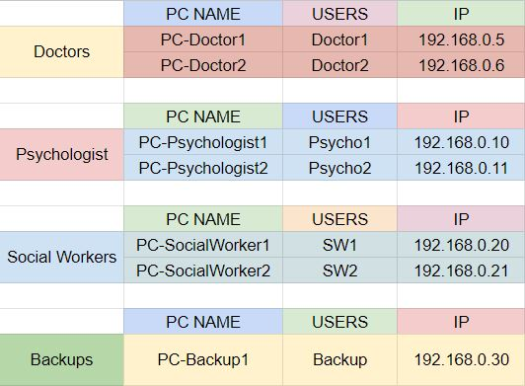

**GPO:**

The users have some GPO installed like, to prevent them from using the CMD, we have put this so that they cannot type any command that they should not be using. This GPO is applied to all users except the administrators.

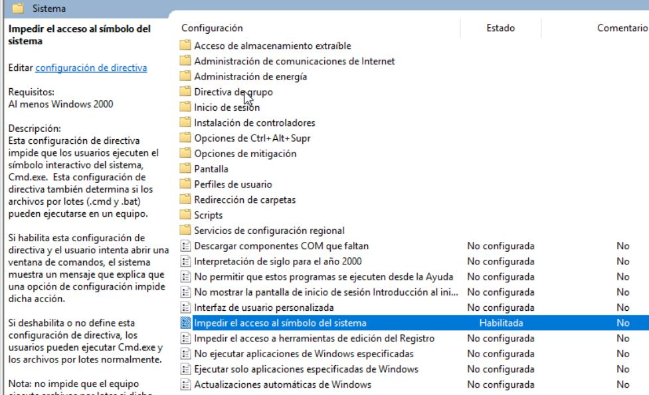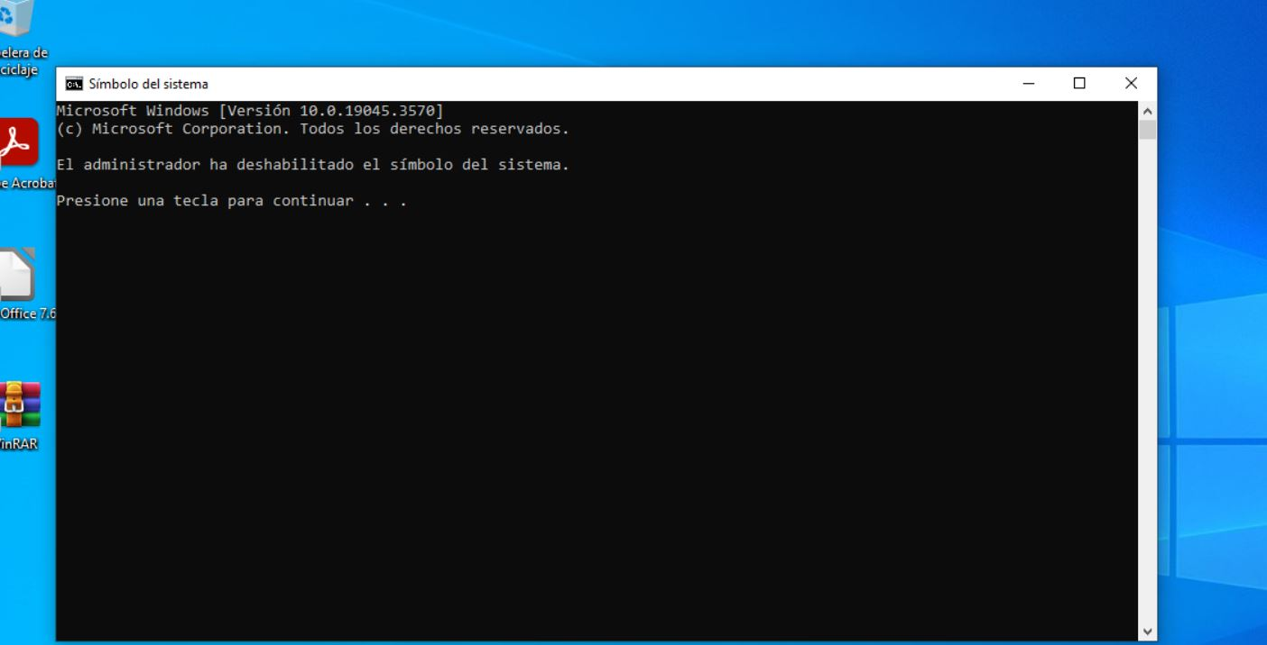

Users once created are given a password, but when they log in for the first time they will have to change it, for this we have created a policy that is configured as follows:

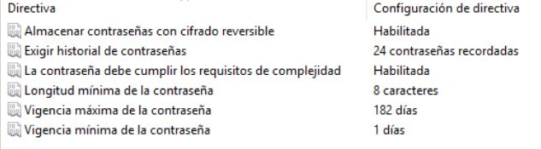

Then we have another GPO which is to put our logo on the background of the computers. We have put this to know which computers belong to our domain and because it is the logo of our organization.

For that, firstly we have to activate the active desktop, and then put the image, with her respective path.

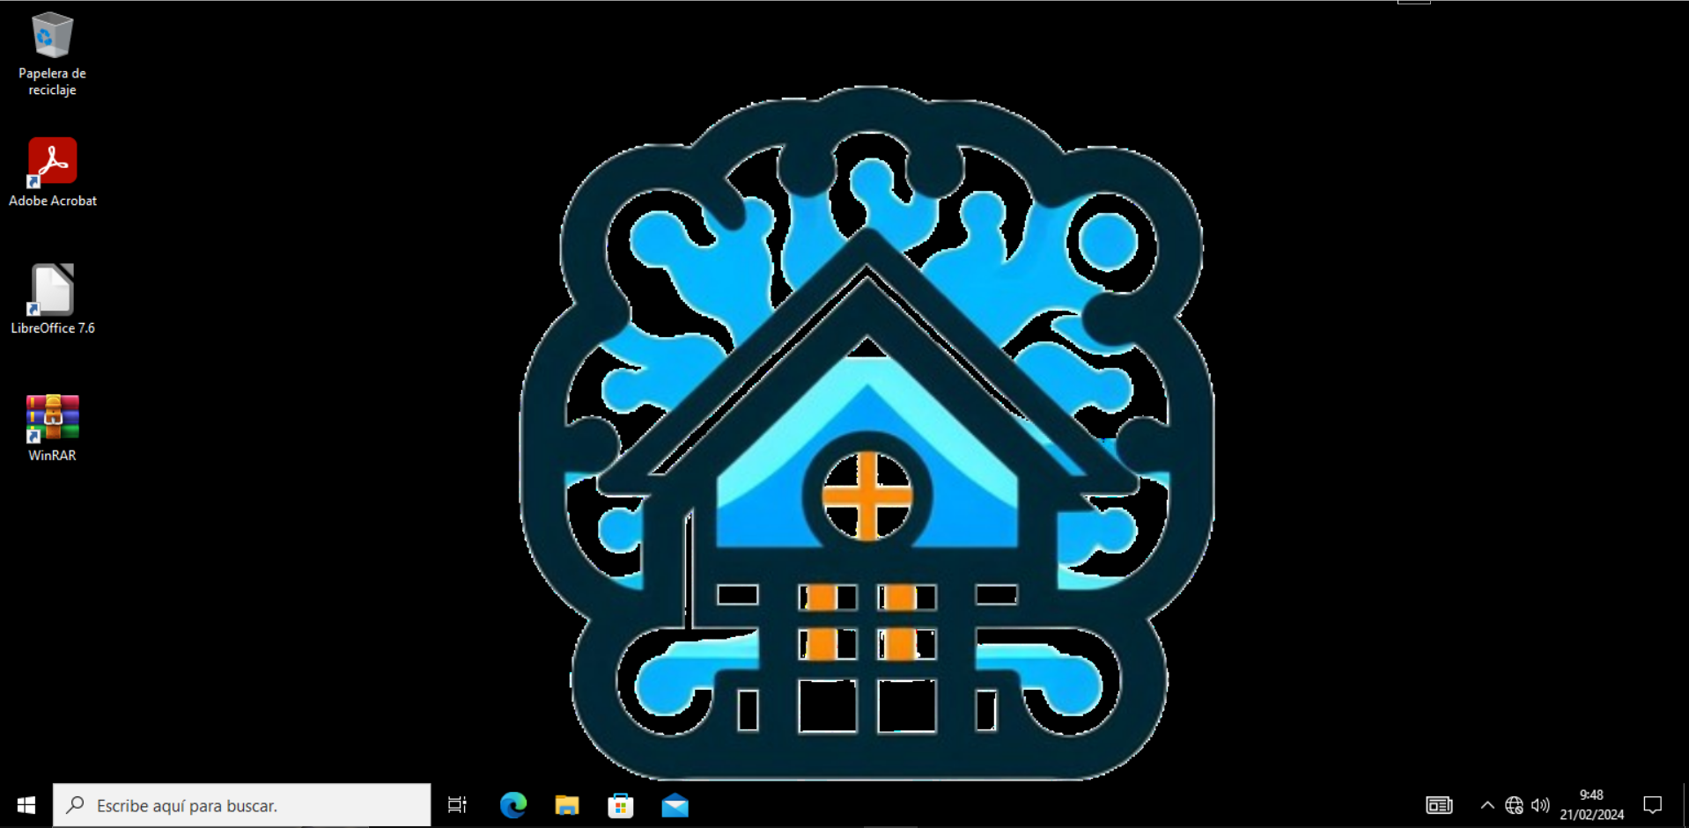

**Assignment of units:**

The shared folders are mapped to network drives so that users can see the folder as a drive. This way they don't have to look for the server in the access path.

All user groups have one assigned to them.

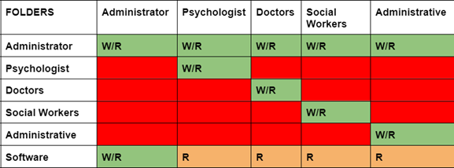

Here you can see how the ‘Doctor1’ user sees the assigned unit.

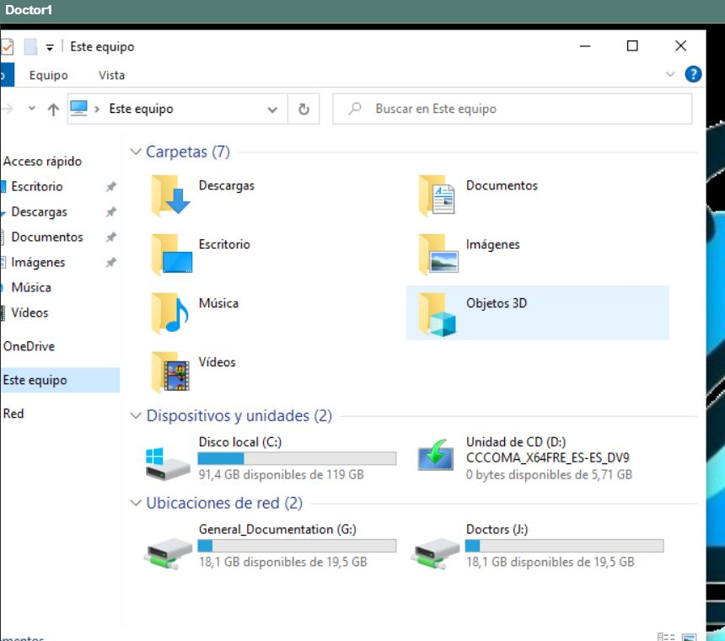

The mapped drives must also be done from Group Policy Management. These would be all the GPO that we have created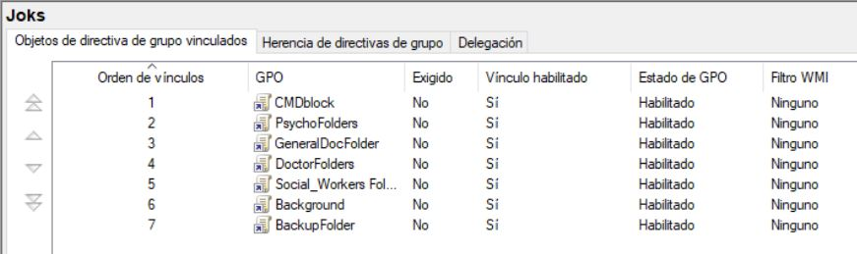

**DNS:**

For the server we have also installed the DNS protocol, what it does is that it translates the IP's to 'real name'. That is to say, the IP '192.168.0.1' translates it to 'SERVER'.

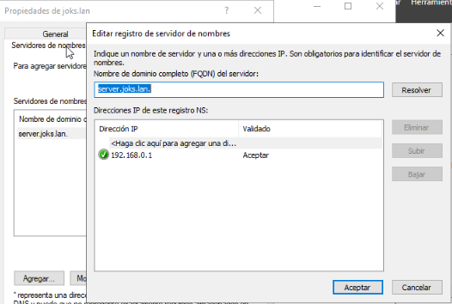

**DHCP:**

In the server we have the DHCP protocol that is responsible for assigning automatic ip to the equipment in our case, we have the range 200 -250, we have put 50 because we believe that they are sufficient.

For that we have to add the DHCP service, after installing it in 'add features and roles' we create a scope, with the name JOKS, and we put the initial and final ip in this case 192.168.0.200 to the final 192.168.0.250, with a duration of 30 days, and without exclusions.

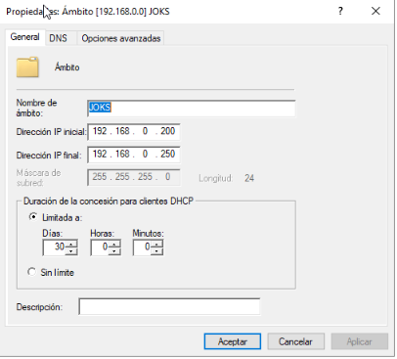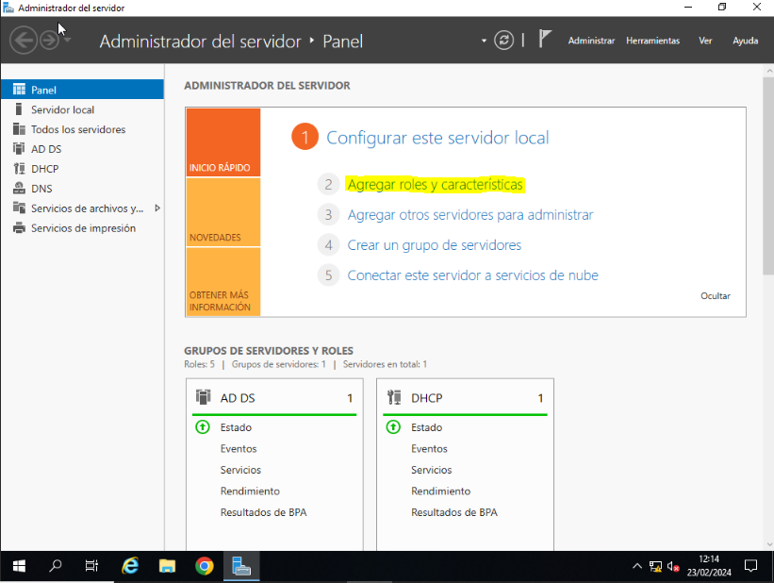

PRINTERS:

For the printers we have installed the printer feature, this also in 'add features and roles', once installed the feature, we have entered in 'manage a printer', and we install the driver 'HPdesignjet 111'

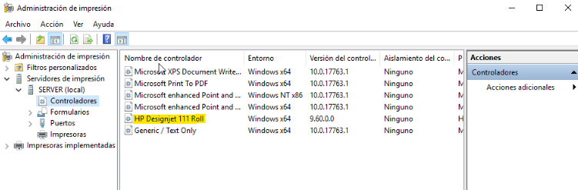 Once installed, we will add the printer, we apply the Ip of the Server when we finish we select properties and we go to the section of sharing and we share with the users.

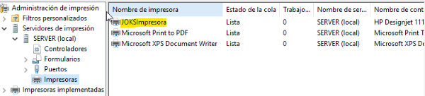

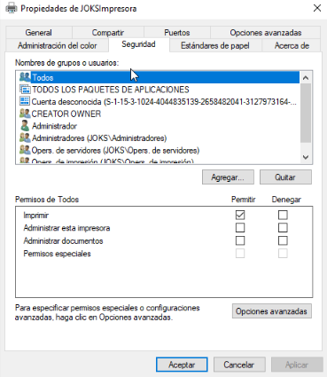

And this is what it would look like for the user 'Doctor_1'.

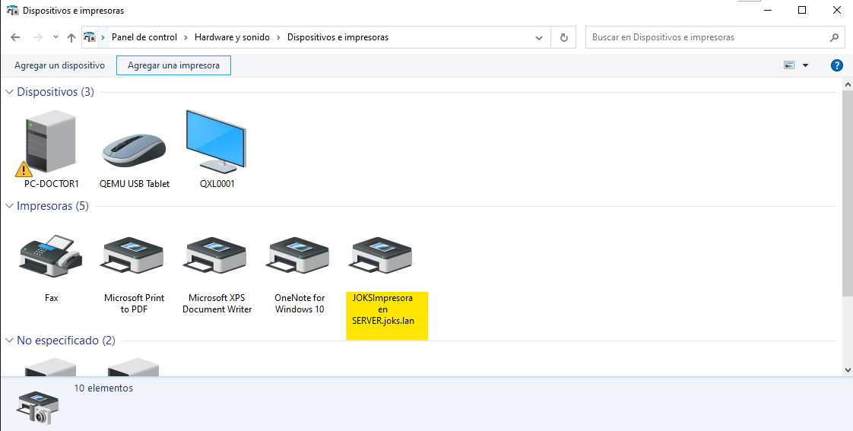

**BACKUPS:**

The windows server has backups made, so that in case of loss we can go back, these backups are made, every day at 12:30.

For that, we will have to add another characteristic in which we will install the backup’s server, and there we will configure, the days, the hours, and where we want to keep them, in our case it would be this way:

Days: All of the week

Hours: 12:30

Where? In the allocation of shared unit in the network.

They are shared in the network with a drive mapping with the computer where the backups are stored. This computer sees the allocation with all the backups inside.

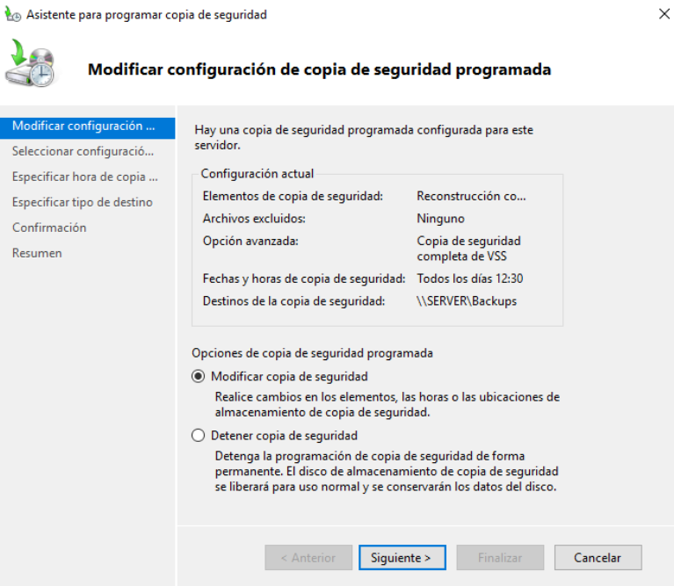

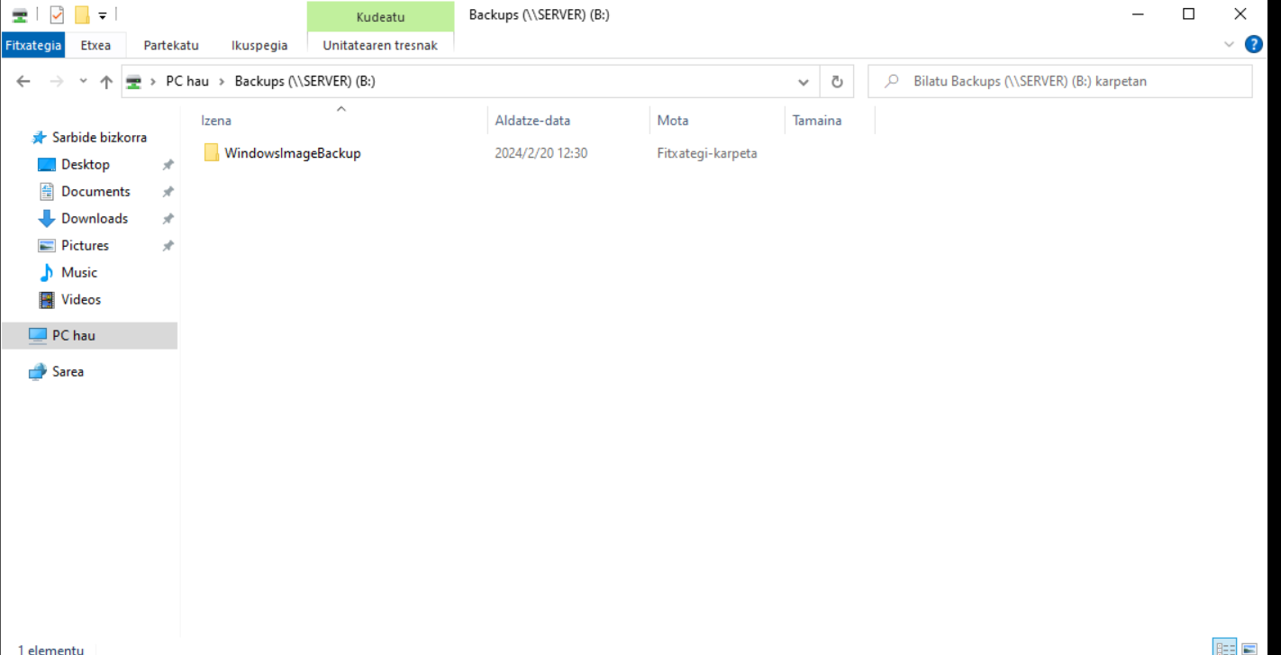

**PACKET TRACER**

To make the network diagram we have used packet tracer, it is a program to simulate networks in which we have 3 Vlans one for each position (Doctors, Social Workers, Psychologist), 4 subnets out of the ip 192.168.5.0.

The first subnet:

192.168.5.0/27

- Network Address: 192.168.5.0

- Broadcast: 192.168.5.31

- Gateway: 192.168.5.1

- Range: 192.168.5.1 - 192.168.5.30

Second subnet:

192.168.5.32/27

- Network Address: 192.168.5.32

- Broadcast: 192.168.5.63

- Gateway: 192.168.5.33

- Range: 192.168.5.33 - 192.168.5.62

Third subnet:

192.168.5.64/27

- Network Address: 192.168.5.64

- Broadcast : 192.168.5.95

- Gateway : 192.168.5.65

- Range: 192.168.5.65 - 192.168.5.94

The fourth subnet:

192.168.5.96/27

- Network Address: 192.168.5.96

- Broadcast: 192.168.5.127

- Gateway: 192.168.5.97

- Range: 192.168.5.97 - 192.168.5.126

Within each VLAN, we have put a printer for each group of workers, i.e. doctors will have a printer just for them, social workers the same, and psychologists the same.

Here you can see our network:

